IMAT2722 Applied Artificial Intelligence
Zakaria Boutarfa P2855274

Deep learning for Rice variety classification: A CNN approach.

Introduction
This project aims to construct a Convolutional neural network model to perform image classification on a large dataset of rice images. The model is designed to correctly label any image as one of the five different classes that represent the output. Our goal is to get the deep learning model as closer as possible to stability and accuracy; to do so we explored multiple aspects of optimization. For instance, data augmentation, network topology, etc.

Methodology
Our method relies on starting with pre-trained convolutional neural networks made available on MATLAB deep learning toolbox. We mainly used AlexNet for different experiments, However, we also tried different models such as SqueezeNet, Resnet-50 and VGG-16. For each pre-trained model, we had to delineate the layers we would use for our final model. Once identified, we would add to these latest new layers that can adjust the pre-existing layers to our rice classification problem requirements (number of classes). We processed our data before training by normalizing it and applying augmentation. Finally, following training, we were able to measure the model’s effectiveness via accuracy and loss as main metrics.

Experimental design
Our In order to build the most optimal model, we made different experiments:
First, we modified the training/validation ratio as we made it vary between 55% to 90% to find the best balance between learning and generalization (figure1). Secondly, we adjusted the data augmentation parameters (pixel range, reflection) to determine the optimal configuration (figure 2). Thirdly, we tried out different model architecture including SqueezeNet, AlexNet. We also modified the final layers architecture by adding fully connected layers and dropout layers (figure 3). Also, we compared optimization methods such as Adam and SGDM (Stochastic Gradient Descent with Momentum), our experiments provided better results with Adam. Finally, we tuned the training options (mini batch sizes & learning rate) by make them vary simultaneously within a limited number of values to find the combination with highest accuracy results (figure 4).

Results
-Optimal training/validation ratio has been found to be 88%, which ensured sufficient training and robust validation. (figure1)
-Optimal pixel range and reflection parameters were respectively [-30 30] & True, which improved generalization and reduced overfitting. (figure2)
-SqueezeNet has shown deceiving results that may be due to its 1*1 convolutional layer instead of a fully connected one. Resnet and VGG showed balanced results. However, the best architecture was by using AlexNet starting configuration with a supplementary fully connected layer. (figure 3)
-Optimal training options were to choose Adam over SGDM, coupled with a learning rate of 1e-4 and a batch size of 28. (figure 5)

Conclusion
This project successfully achieved accurate rice image classification task with its final form reaching 100% accuracy, proving that a well-tuned transfer learning approach using a relevant pre-trained CNN. Adjusting training/validation split, augmentation parameters, training options represented a critical aspect of the work done. On top of that, discovering new network topologies helped in finding a reliable pre-trained network that we can add on to it with optimization. Future improvements could include more network architectures, optimizations methods other than Adam and SGDM and more accuracy in determining optimal parameters to take our model’s performance to another level.

Appendix
Figure1 Figure2

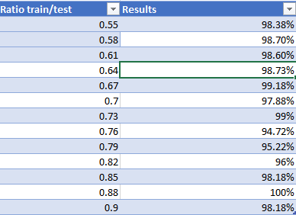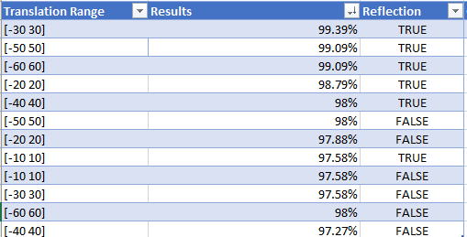
Figure 3
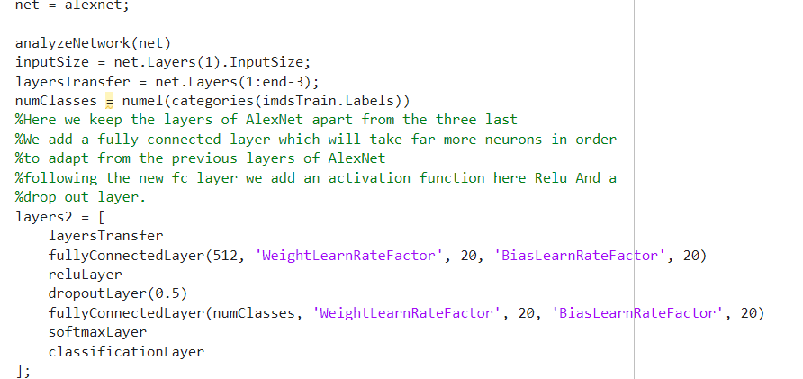
Figure 4
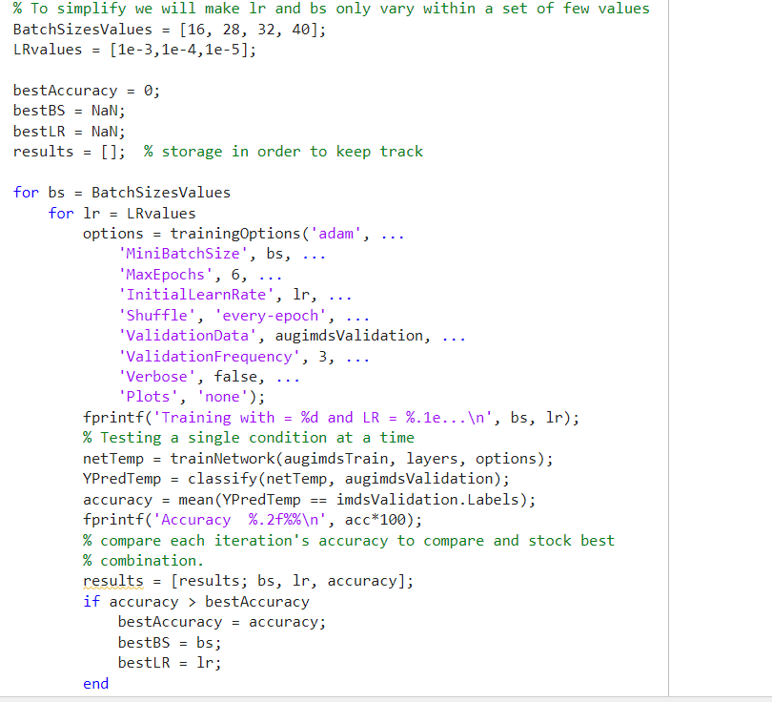
Figure 5

Reference List

- YouTube. Available at: https://www.youtube.com/watch?v=DAOcjicFr1Y&ab_channel=StanfordUniversitySchoolofEngineering.
- Rezasemyari (2023) Rice image classification: CNN: 0.99, Kaggle. Available at: https://www.kaggle.com/code/rezasemyari/rice-image-classification-cnn-0-99#TensorFlow.
- (No date a) YouTube. Available at: https://youtu.be/zfiSAzpy9NM?si=meRsenUZZyDTQ5LR.

-Thrun, S., Burgard, W. and Fox, D. (2005), Probabilistic Robotics. 1st edn. Cambridge, MA: MIT Press.
-Welch, G. and Bishop, G. (2006), ‘An Introduction to the Kalman Filter’. University of North Carolina at Chapel Hill, Department of Computer Science, TR 95-041.
-W3Schools, ‘Python Tutorial’. Available at: https://www.w3schools.com/python/ (Accessed: 5 February 2025).
-Bar-Shalom, Y., Li, X.R. and Kirubarajan, T. (2001), Estimation with Applications to Tracking and Navigation. New York: John Wiley & Sons, Inc.
- Pr. Nathanel Baisa. (2024), Lecture slides from Intelligent Robotics IMAT2721.

Appendix A
Testing additional experiment
default
Low:(Figure 3&4)
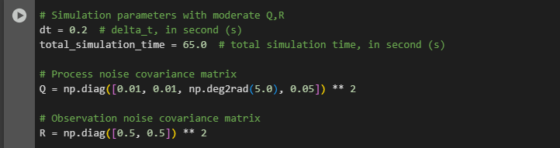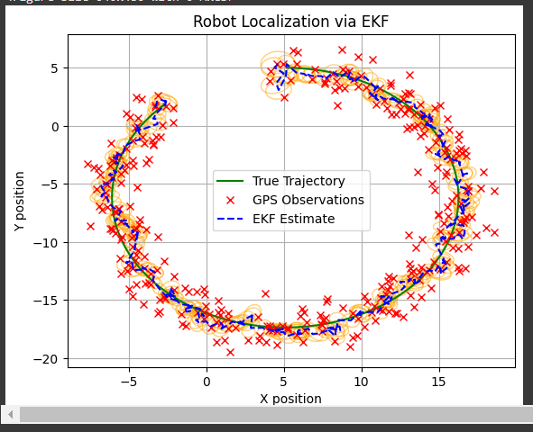
High:(Figure 1&2)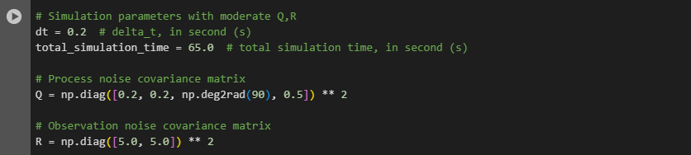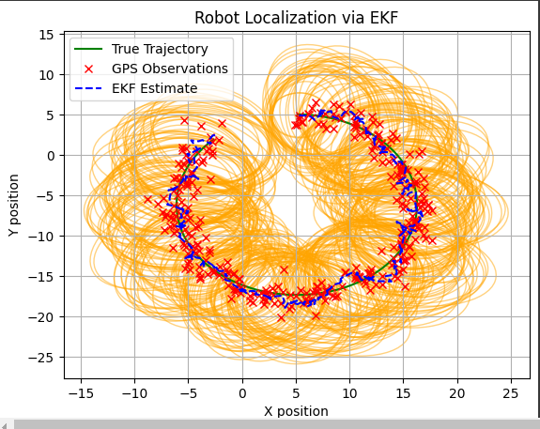
Moderate: (Figure5&6)
